**Diversifying your professional networks**

We are all familiar with the phase “its not what you know, but who you know”.  Networks and effective networking is critical to career development but, for ethnically diverse colleagues it can be much harder to build an influential and helpful network.

We looked at networking from two perspectives; firstly thinking about how diverse our professional and personal networks are and the secondly thinking about what our networks can do for us. Specifically, are our current networks working hard enough for us?

David Codner from L&Q led the first session inviting us to think about **who** was in our networks; how diverse are they? While for the ethnically diverse colleagues in the room, both mentees and Change Champions, their personal and professional networks were quite diverse, It was less so for our white colleagues. **We concluded that people’s networks, where we were not intentional about them, tended to be made up of people like them. We further concluded that breath of thought and ideas comes from more diverse networks.**

The idea of being intentional about networks was built on by Elaine. She talked to us about having a ‘**Personal Boardroom**’ of people that supported us and our career development in different ways. Attached is the list of potential contributors to our Personal Boardrooms. We were asked to think about who we had in our current Boardroom and the roles they played. We were then asked to be quite Machiavellian about it and to think about how we could maximise these relationships as they are ….. but also …. as they could be; was everyone in our Boardroom useful? do they need adding to or replacing? Do any gaps need filling?

Elaine also invited everyone to think about whose Personal Boardroom they were in and whether they could accentuate and elevate their roles for the good of the individual’s whose Boardrooms they are in.

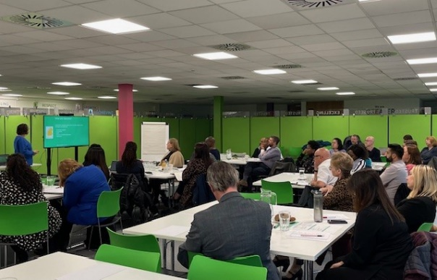Julia then took us through some network theory, introducing us to the concept of **Bonding Networks** and **Bridging Networks**; Bonding being those that are familiar and give support and a sense of belonging and Bridging being those that enable access to resources, partnerships and other connections. She also gave us a new word; **Homophily** – the love of sameness. She explored how networks can be cliques with hidden rules and hierarchies, which all need to be understood and negotiated. **We talked about our Movement of Change as a positive network, members of which could make up our Personal Boardrooms or be Bridging to other advantageous networks.**

Finally recognising that networking is hard and difficult, Karen shared with us the thoughts and insecurities of introverts when the word ‘networking’ comes along. **We agreed all people dreaded the word ‘networking’ and we had to re-frame to make it ‘meeting interesting people’ and ‘being curious**’. **Julia invited us all to make sure that we approach the lone person in the room when we attend events and start a conversations, especially if they are ethnically diverse.**

**Karen had two strong pieces of advise**

* **have a plan - identify what networks you may need/ the type of people you need to meet**
* **have a personal narrative – identify who you are, what you care about and why others may want to work with you**

Mentees shared concerns about approaching people they identified as being helpful to them. Elaine encouraged people just to make contact and ask. Most people are willing to help others and would be more than happy to. She suggested asking people for their time over a coffee, explaining what they need help with and asking for some support or coaching on it. Maxine Cousens added that having a genuine interest in people and being authentic with them is important – don’t just wait to contact people when you need something specific; keep in touch, met regularly, note their LinkedIn posts, drop them an e-mail, in short, build trust

The second part of the afternoon was dedicated to Legacy – Legacy for each individual but also of the programme itself.

**Making the most of the next 6 months, and beyond**

We re-capped on the GROW model. Most agreed that it was a good framework but were tweaking it to get the best out of it. Brian Moran and Shabana Hameed shared how they were using the model and how it had worked for them – see note below to see how successful it has been!

Boost is going to hold a session for L&D teams and each Mentees Line Manager to discuss the transition from the mentoring under Boost at the end of the programme back into the career development systems at each host organisation. We will also look at learning from the programme – Are their barriers for ethnically diverse colleagues accessing or benefitting from learning interventions, training etc.

We also looked at the role of intersectionality, specifically around gender.

**What is our aspiration for Boost?**

At our last Movement of Change meeting, Sharon Amusu had challenged us about what we wanted our Boost legacy to be. As a ‘starter for ten’ Julia shared with us the attached draft statement.

**We invited everyone to reflect on this and bring their ideas to the January meeting.**

Julia shared that Riverside as they had created a Boost Strategy within their organisation to pick up and embed the learning.

**Celebrating Success**

Finally we celebrated two successes in the room – Brian Moran, one of our Mentors has just been promoted to CEO of Jigsaw and, hot off the press, Shabana Hameed, his Mentee has been promoted to Director of Risk, Assurance & Improvement at Your Housing Group. What a golden couple!

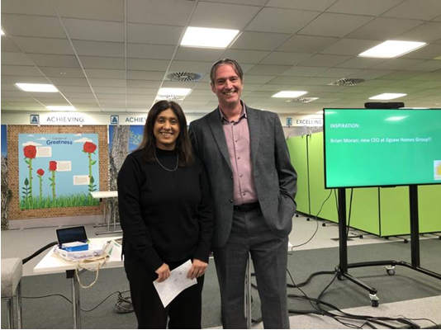**Brian Moran** provided some great insight and advice to the group. He reflected on how Steve Jobs gave a talk to university graduates to explain that is it easy, at the end of your career, to track back and understand how you got to where you were going … but it is hard at the beginning to understand how you get to where you want to go. He also reflected on what he had learnt from the Mentoring relationship with Shabana – he said he did not think he was ambitious but realised, after talking with Shabana, that he was driven by a goal to be be independent.

              His advice for all was

* *Work hard*
* *Change your job every 2 years – this included promotions in the same organisations. He advised to keep learning and keep moving upwards – don’t get ‘stuck’ in one role*
* *Take opportunities when they present themselves, even if they are out of your ‘comfort zone’. Learn to be ‘comfortable with being uncomfortable’*
* *Work for organisations that share your values*
* *It takes time – Brian’s CEOship has been 17 years in the making!*

Shabana reflections were

* *Use your Mentor; have great conversations*
* *As an Asian woman, she was waiting for someone else to be a role model for her; she decided to be courageous and move out of her comfort zone to be that person for others*
* *Like Brian she stressed the importance of working hard and being good at what you do*

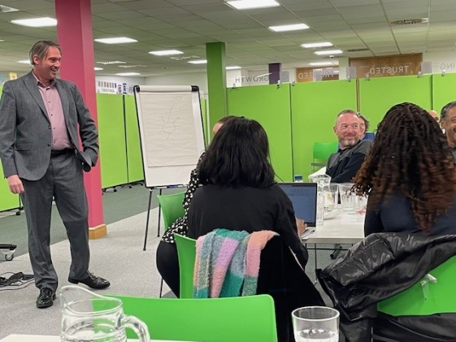You may also note the return of a very welcome face on this last picture on the right,  Mark Leith joined us for the meeting, which was lovely!

See you in January – make sure the time and date is in your diary – 1.30pm on 22nd . This session will be about Inclusive Recruitment. Would be great to see those that haven’t made it to a movement meeting yet.